**Execute with one example Lambda Functions in Python**

In Python, a lambda function is an anonymous function defined using the **lambda** keyword. Lambda functions are often used for short and simple operations where a full function definition is not necessary.

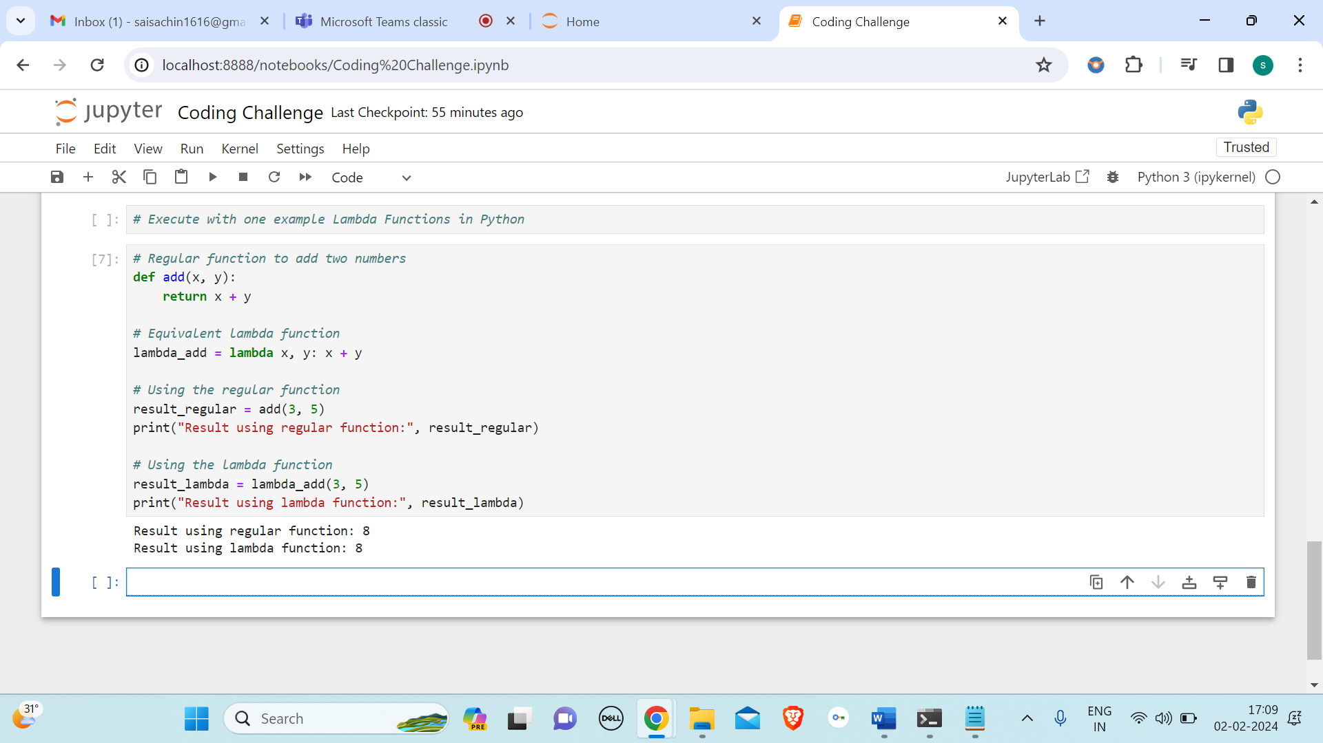

In this example, **lambda_add** is a lambda function that takes two arguments (x and y) and returns their sum. The result is then printed using both the regular function (add) and the lambda function (lambda_add).

**Read JSON Strings to Python dicts or lists**

We can do 2 ways to read JSON strings to python dictionary or lists, namely:

* We will write a sample JSON string in the code itself and convert the JSON string to python dictionary.
* Secondly, we will load the JSON string in the code and convert the JSON string to python list.

JSON Strings to Python Dictionary

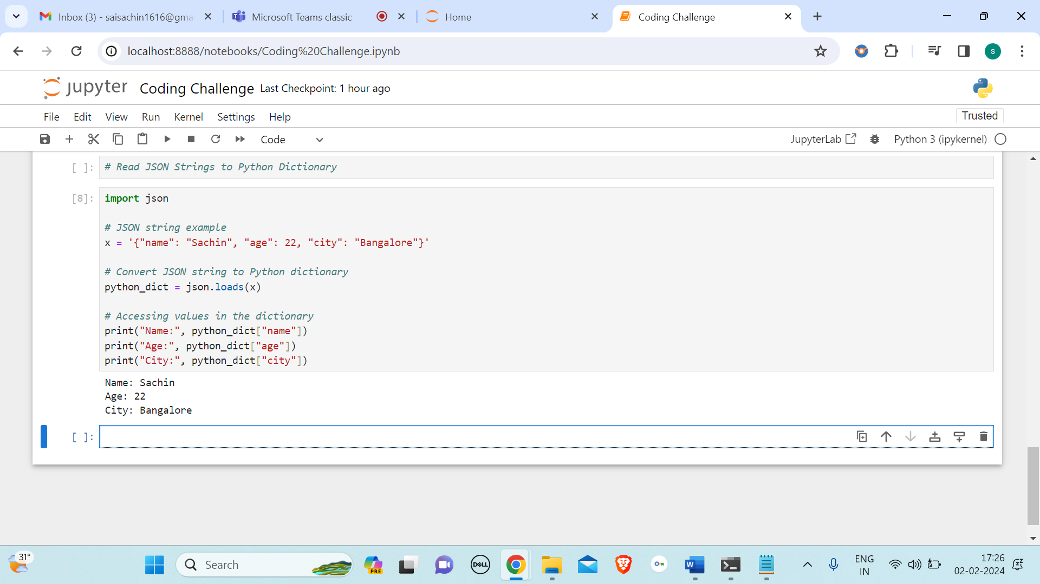

* JSON is a Python module that provides methods for working with JSON data.
* The variable x contains a JSON-formatted string representing a person's information (name, age, and city).
* **json.loads(x)** is used to convert the JSON string (x) into a Python dictionary (python_dict).
* The values in the dictionary are accessed using keys ("name," "age," and "city").
* Finally, the code prints out the person's name, age, and city.

Read JSON Strings to Python list

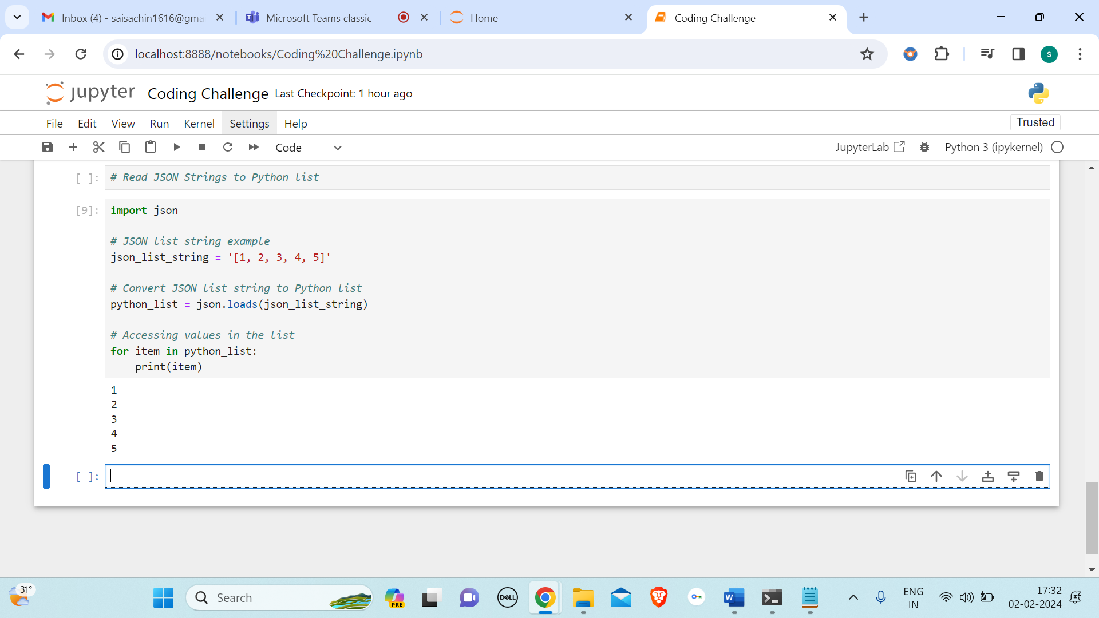

* **json_list_string**: A string containing a JSON-formatted list [1, 2, 3, 4, 5].
* **json.loads(json_list_string)**: Converts the JSON string into a Python list, storing it in the variable python_list.
* **print(item)**: Prints each element of the list.